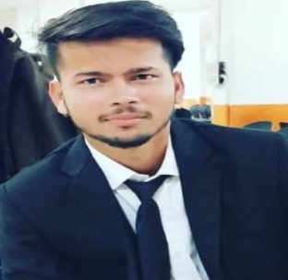



manmohankumar023@gmail

Manmohan Kumar

Full Stack developer

To have a growth oriented and challenging career, where I can contribute my knowledge and skills to the organization.



+91-9218100126



Baddi, HP, India



<https://www.linkedin.com/>in/manmohan-kumar-67075719a/

https://github.com/themanmohan

# https://manmohan.netlify.app

# **SKILLS**

**EDUCATION**

## **B.tech (Computer Science and Engineering)**

Lovely Professional University, Phagwara

*2017 – 2021*

## **12th (HP Board)**

Shivalik Science School, Kharuni, HP

*2016 – 2017*

## **10th (HP Board)**

Shivalik Science School, Kharuni, HP

*2014 – 2015*

*6.41/10*

*73.00 %*

*83.00%*

# **PERSONAL PROJECTS**



C

C++

Python

### Lets Farm (02/2021 – 04/2021)

DBMS

MongoDB

This project was capstone project. The aim of the project was to give proper information about farming and expert assistance to farmer. Technologies used were HTML, CSS and JavaScript Nodejs, Express, MongoDB, ejs.

MySQL

HTML

CSS/SASS

Javascript

### URS (university Review System) (11/2018 – 12/2018)

This project was written in Node js language. By the help of this project we can add, view, and delete the university information. And also give the review and rating to the university Technologies used were HTML, CSS and JavaScript Nodejs, Express, MongoDB, ejs.

Express

Nodejs

Express

Nodejs

React

Redux

### Mobile Shop (02/2018 – 04/2018)

This project was written in React which is JavaScript Library On this website user will get information about different kind of Mobile and user also able to add product to cart

php

SEO

### Github User Finder (02/2018 – 04/2018)

This project was written in JavaScript, HTML, CSS language. By the help of this project we can find the GitHub user and get the information about the GitHub user and about repository.

# **LANGUAGES**

English

    

Hindi

    

**HOBBY**

Football

**CERTIFICATIONS / TRAININGS**

Front-End Web Development with React ( 6/2020)

*Coursera*

Server-side Development with NodeJS, Express and MongoDB (1/2020)

*Coursera*

### Web Development (6/2019 - 8/2019)

*Internshala*

### Programming with C and C++ (6/2019 - 8/2019)

*Internshala*

### SEO (2020)

*eMarketing Institute*

Cricket